Revision | Date | Revision History | Approved
- | 12/23/2008 | PRODUCTION RELEASE

Specification Control Drawing

Radio Frequency Equipment (RFE) Assembly

Document No. 108817

Release Authority
JOB TITLE | PRINTED NAME | SIGNATURE | DATE
Mechanical: | Steve Bellantone
Electrical: | Chuck Faraci
Q.A.: | Jim Muise
Table of Contents
1 Scope 4
2 Applicable Documents 4

2.1 Government Documents 4
2.1.1 Specifications 4
2.1.2 Standards 4
2.1.3 Drawings 4
2.1.4 Other Publications 5

2.2 Non-Government Documents 5
2.2.1 Specifications 5
2.2.2 Standards 5
2.2.3 Drawings 5
2.2.4 Other Publications 5
3 Requirements 6

3.1 Item Definition 6
3.1.1 Item BOM 6
3.1.2 Item Diagrams 7
3.1.3 External Interface Definition 7

3.2 Characteristics 14
3.2.1 Performance Characteristics 14
3.2.2 Control and Status Devices 25
3.2.3 Physical Characteristics 28
3.2.4 Cooling 28
3.2.5 Reliability 28
3.2.6 Maintainability 28
3.2.7 Environmental Conditions 29

3.3 Design and Construction 34
3.3.1 Materials, Processes, and Parts 34
3.3.2 Electromagnetic Interference (EMI) / Electromagnetic Compatibility 35
3.3.3 Product Marking 35
3.3.4 Workmanship 35
3.3.5 Interchangeability 35
3.3.6 Safety 35

3.4 Precedence 36
4 Quality Assurance Provisions 36

4.1 Acceptance Requirements 37
4.1.1 Verification Matrix 37

4.2 Test Data and Certifications 37
5 Preparation for Delivery 41
6 Notes 41

6.1 Intended Use 41

6.2 Acronyms and Abbreviations 41

Table of Tables
Table 1 – RFE Assembly BOM 6
Table 2 – External Interface Definition 8
Table 3 - J11 Pin Configuration 8
Table 4 - J12 Pin Configuration 9
Table 5 - J13 Pin Configuration 9
Table 6 – J20 Pin Configuration 10
Table 7 - J18 Connector Configuration 10
Table 8 - J19 Connector Configuration 10
Table 9 - RF Over-the-air Receive Input Interface Characteristics 11
Table 10 - Receive Output Interface Characteristics 11
Table 11 - Transmit Over-the-air RF Interface Characteristics 12
Table 12 - Transmit Input Interface Characteristics 12
Table 13 - CDL Amplitude Variation 21
Table 14 - Intelsat Amplitude Variation 22
Table 15 - Ku-Band CDL/NCDL Group Delay Variation 23
Table 16 - X-Band CDL Group Delay Variation 24
Table 17 - Intelsat Group Delay Variation 24
Table 18 – LNA Current Monitor Definition 25
Table 19 – Definition of RF Switch Commands 26
Table 20 – RF Switch Commands for Circular Polarization Control 27
Table 21 – RF Switch Commands for BIT Mode 27
Table 22 – Definition of RF Switch Status 27
Table 23 – RF Switch Status for Circular Polarization Control 27
Table 24 – RF Switch Status for BIT Mode 28
Table 25 - EMI/EMC Requirements 35
Table 26 - Requirements Verification Matrix 37

Table of Figures
Figure 1 – RFE Functional Block Diagram 7
Figure 2 Diplexer Characteristics – Ku-Band STD-CDL FL/N-CDL OL Channel 16
Figure 3 Diplexer Characteristics – Ku-Band STD-CDL RL/N-CDL IL Channel 17
Figure 4 Diplexer Characteristics – X-Band STD-CDL FL 18
Figure 5 Diplexer Characteristics – X-Band STD-CDL RL 19
Figure 6 Filter Characteristics – Intelsat Uplink Characteristics 20
Figure 7 Filter Characteristics – Intelsat Uplink Characteristics 21
Figure 8 - Amplitude Variation 23
Figure 9 - Group Delay Variation 25
Figure 10 – Transformational Vibration, Non-Operational 31
Figure 11 - Operational Vibration Spectrum 32
Figure 12 - Endurance Vibration Spectrum 33

Scope
This specification establishes the performance, design, development, and test requirements for the Radio Frequency Equipment (RFE) & Reflector Hub Assembly. For purposes of this specification, this may be referred to as the RFE.

Applicable Documents

Government Documents
The following documents, of the issue in effect at the time of invitation for bids or the exact issue specified, form a part of this drawing to the extent specified herein. In the event of a conflict between the documents referenced herein and the contents of this specification, the contents of this specification shall be considered a superseding requirement.

Specifications
Government specifications referenced in this specification are as follows:
DOCUMENT TITLE
MIL-A-8421F Air Transportability Requirements, General Specification for
MIL-E-17555 Electronic and Electrical Equipment, Accessories, and Provisioned Items (Repair Parts): Packaging of
MIL-E-4158E Electronic Equipment, Ground, General Requirements for

MIL-DTL-5541F Chemical Conversion Coatings on Aluminum and Aluminum Alloys

Standards
Government Standards referenced in this specification are as follows:
DOCUMENT TITLE
MIL-STD-129J Marking for Shipment and Storage
MIL-STD-130N Identification Marking of U.S. Military Property
MIL-STD-1472F Human Engineering Design Criteria for Military Systems, Equipment and Facilities
MIL-STD 1686A Electrostatic Discharge Control Program for Protection of Electronic Parts, Assemblies and Equipment
MIL-STD-454J Standard General Requirements for Electronic Equipment
MIL-STD-461F Electromagnetic Emission and Requirements for the Control of Electromagnetic Interference
MIL-STD-704E Aircraft Electric Power Characteristics
MIL-STD-810F Test Method Standard for Environmental Engineering Considerations and Laboratory Tests
MIL-STD-882B System Safety Program Requirements
MIL-STD-889B Dissimilar Metals

Drawings
Government Drawings referenced in this specification are as follows:
None

Other Publications
Other government publications referenced in this specification are as follows:
DOCUMENT TITLE
MIL-HDBK-454A General Guidelines for Electronic Equipment
MIL-HDBK-5400 Electronic Equipment, Airborne, General Guidelines for

Non-Government Documents
The following documents of the exact issue shown form a part of this specification to the extent specified herein. In the event of conflict between the documents referenced herein and the contents of this specification, the contents of this specification shall be considered a superseding requirement.

Specifications
Non-Government specifications referenced in this specification are as follows:
DOCUMENT TITLE
40009096 Antenna Group – Fixed Surface Terminal Critical Item Development (L-3 Communications West)
8164036 Environmental Requirements Specification for the Multi-Role Tactical Common Data Link System (L-3 Communications West)

Standards
Non-Government Standards referenced in this specification are as follows:
DOCUMENT TITLE
IPC/WHMA-A-620 Requirements and Acceptance for Cable and Wire Harness Assemblies

Drawings
Non-Government Drawings referenced in this specification are as follows:
DOCUMENT TITLE
108818 Mechanical Outline, RFE (AMC)

Other Publications
Other Non-Government publications referenced in this specification are as follows:
DOCUMENT TITLE
RTCA/DO-160D Environmental Conditions and Test Procedures for Airborne Equipment
STANAG 2895 Extreme Climatic Conditions and Derived Conditions for use in Defining Design/Test Criteria for NATO Forces Materiel
ETS 300 19-1-4 Introductory Element Equipment Engineering (EE); Environmental Conditions and Environmental Test for Telecommunications Equipment Part 1-4: Classification of Environmental Conditions Stationary Use at Non-Weatherprotected Locations
ATP1067391 Acceptance Test Procedure (CMT)

Requirements
Each assembly shall comply with the following requirements that shall be guaranteed by the manufacturer and achieved through design and process control. Testing of these requirements may be performed, but is not required, except as specified in paragraph 4.

Item Definition
The RFE shall provide RF transmission paths for full-duplex links on a Common Data Link (CDL) Ku-band RF signal, a Network Common Data Link (N-CDL) Ku-band RF signal, or a CDL X-band RF signal through either Omni Widebeam(WB) or Narrow-Beam(NB) antenna ports. In addition, the RFE shall provide RF transmission paths for a Ku-band Intelsat RF signal for satellite communications through the NB port.
The RFE shall support the following operational modes:
Transmit in Ku STD-CDL return link (RL) and receive in Ku STD-CDL forward link (FL)
Transmit in Ku STD-CDL FL and receive in Ku STD-CDL RL
Transmit in X STD-CDL FL and receive in X STD-CDL RL
Transmit in Ku N-CDL inbound link (IL) and receive in Ku N-CDL outbound link (OL)
Transmit in Ku N-CDL outbound link (OL) and receive in Ku N-CDL inbound link (IL)
Transmit in Ku Intelsat uplink and receive in Ku Intelsat downlink
Antenna Polarization selection for the appropriate mode
Antenna 1 or Antenna 2 selection
RF BIT Loop function
The selected transmit signal shall be received from the antenna pedestal, conditioned for transmission to an antenna feed and the receive signal shall be received from the antenna feed, low-noise amplified, and conditioned for transmission to the antenna pedestal.

Item BOM
In addition to all RF, electrical, and mechanical components required to meet this specification, the RFE will consist of the items listed in Table 1. Hardware tems listed will be bagged and tagged and shipped as loose items or temporarily mounted to the RFE. Items not listed such as gaskets, fasteners, and other hardware but must be supplied to provide a complete RFE Assembly.

Table 1 – RFE Assembly BOM
Level |  | Description | P/N | Qty.
1 |  | Mechanical Outline, RFE | AMC 108818 | Ref.
1 |  | Bulkhead Mount Hardware
 | 2 | Screw, Pan Head, SS, 6-32UNC X | MS51957-28 | 8
 | 2 | Washer, Lock, SS, #6 | MS35338-136 | 8
 | 2 | Washer, Flat, SS, #6 | NAS1149CN632R | 8
1 |  | Base Plate Mounting Hardware
 | 2 | Screw, Socket Head Cap, SS, 1/4-20UNC x 3/4 | MS16995-50 | 4
 | 2 | Washer, Lock, SS, 1/4 | MS35338-139 | 4
 | 2 | Washer, Flat, SS, 1/4 | MS15795-810 | 4
1 |  | Box Gaskets
 | 2 | Gasket, D-Strip, 1/16 X .085 | 19-05-E163-1298 | 1 @ 65”
 | 2 | Rod, .070” Dia., Silicone, AgAl | 10-04-1687-1298 | 2 @ 12”
1 |  | Dual E-Bend/Rotary Joint Hardware
 |  | Screw, Socket Head Cap, SS, 6-32UNC X 1/2 | MS16995-18 | 10
 |  | Washer, Lock, SS, #6 | MS35338-136 | 10
 |  | Mechanical Stop | 1056102 | 1
 |  | Conductive Gasket, WR75 | 103039-005 | 4
1 |  | Cover & Side Plate Hardware
 |  | Screw, Pan Head, SS, 4-40UNC X 5/16 | MS51957-14 | 84
 |  | Screw, Pan Head, SS, 4-40UNC X 3/8 | MS51957-15 | 4
 |  | Washer, Lock, SS, #4 | MS35338-135 | 88
 | 2 | Acceptance Test Procedure | CM ATP1067391 | Ref.

Item Diagrams
The RFE shall be represented by the functional block diagram shown in Figure 1.
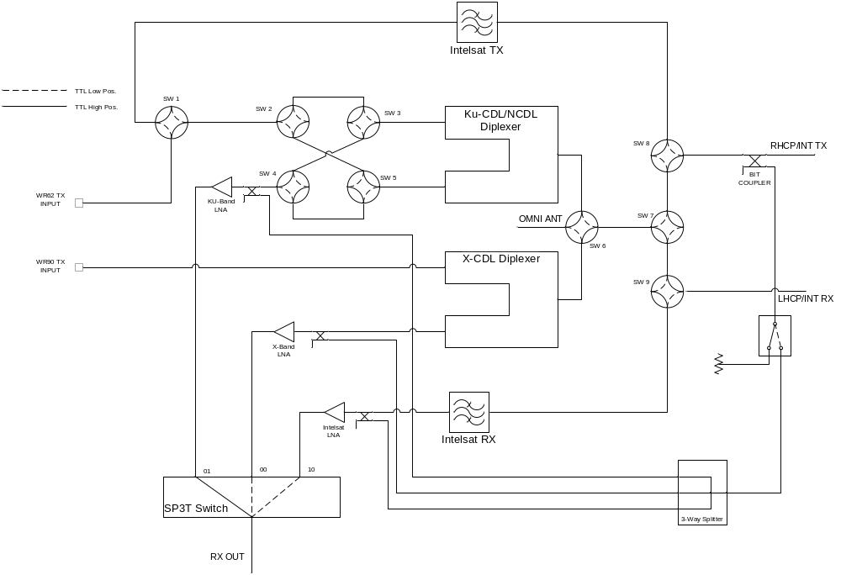
Figure 1 – RFE Functional Block Diagram

External Interface Definition
The RFE external electrical interfaces shall be designed according to Table 2, which shows the connector designator, connector part number, and the basic interface function.
Table 2 – External Interface Definition
Ref Des | Part Number/Type/  Description | Function
J11 | D38999/24WC35PB | Input from RFE Controller for Polarization Motor and SSPA
J12 | D38999/24WD35PA | Input from RFE Controller for RFE
J13 | D38999/24WD18SC | Output to SSPA
J18 | PRECISION N-F | Receive RF Output
J19 | SMA-F | Omni Wide Beam Antenna Feed Interface
J20 | D38999/24WC98SN | Output to Polarization Motor
 | WR62 Waveguide Flange | Ku Band Transmit
 | WR90 Waveguide Flange | X Band Transmit
 | WR75 Waveguide Flange | Antenna Feed Interface (RHCP/Intelsat TX)
 | WR75 Waveguide Flange | Antenna Feed Interface (LHCP/Intelsat RX)

Power and Command Connector Definition
The RFE J11 connector shall be designed according to Table 3.

Table 3 - J11 Pin Configuration
Pin | Signal Name
1 | 28 VDC +
2 | VDC RETURN
3 | 28 VDC +
4 | VDC RETURN
5 | 28 VDC +
6 | VDC RETURN
7 | TX+
8 | TX-
9 | RX+
10 | RX-
11 | BLANKING
12 | BLANKING RETURN
13 | NC
14 | NC
15 | PHASE 1 START
16 | PHASE 1 FINISH
17 | PHASE 2 START
18 | PHASE 2 FINISH
19 | SWITCH COMMON
20 | SWITCH NC
21 | SWITCH NO
22 | NC

The RFE J12 connector shall be designed according to Table 4.

Table 4 - J12 Pin Configuration
Pin | Signal Name
1 | +28 VDC
2 | +28 VDC RTN
3 | +28 VDC
4 | +28 VDC RTN
5 | NC
6 | NC
7 | NC
8 | NC
9 | NC
10 | Ku LNA HEALTH
11 | X LNA HEALTH
12 | INTELSAT LNA HEALTH
13 | S1 CONTROL
14 | S1 STATUS
15 | S2 CONTROL
16 | S2 STATUS
17 | S3 CONTROL
18 | S3 STATUS
19 | S4 CONTROL
20 | S4 STATUS
21 | S5 CONTROL
22 | S5 STATUS
23 | S6 CONTROL
24 | S6 STATUS
25 | S7 CONTROL
26 | S7 STATUS
27 | S8 CONTROL
28 | S8 STATUS
29 | S9 CONTROL
30 | S9 STATUS
31 | S10 MSB
32 | S10 LSB
33 | S10 POS 1 STATUS
34 | S10 POS 2 STATUS
35 | S10 POS 3 STATUS
36 | S11 CONTROL
37 | S11 STATUS

The RFE J13 connector shall be designed according to Table 5.

Table 5 - J13 Pin Configuration
Pin | Signal Name
A | 28 VDC +
M | VDC RETURN
B | 28 VDC +
N | VDC RETURN
L | 28 VDC +
K | VDC RETURN
D | TX+
E | TX-
C | SHIELD (Tx)
F | RX+
G | RX-
P | SHIELD (Rx)
H | BLANKING
J | BLANKING RETURN
R,S,T,U | NC

The RFE J20 Connector shall be designed according to Table 6.

Table 6 – J20 Pin Configuration
Pin | Signal Name
A | PHASE 1 START
B | PHASE 1 FINISH
C | PHASE 2 START
D | PHASE 2 FINISH
E | SWITCH COMMON
F | SWITCH NC
G | SWITCH NO
H | SPARE
J | SPARE
K | SPARE

RF Connector Definition
The RFE J18 connector shall be designed according to Table 7.

Table 7 - J18 Connector Configuration
Pin | Signal Name
Pin | Receive RF
Shield | Receive RF Shield

The RFE J19 connector shall be designed according to Table 8.

Table 8 - J19 Connector Configuration
Pin | Signal Name
Pin | OMNI RF
Shield | OMNI RF Shield

Waveguide Port Definition
The RFE waveguide ports shall be located and oriented according to Mechanical Outline AMC 108818. The X-Band and Ku-Band Transmit waveguide ports shall have permanent pressure/debris windows installed.

Receive Input Signal Characteristics

Over-the-air Receive Input Interface
The RFE shall accept the RF signals with characteristics identified in Table 9 from either Widebeam (WB) and Narrowbeam (NB) antenna interface ports. The signal, antenna, and polarization selection is made in accordance with TTL logic commands received via connector J12.

Table 9 - RF Over-the-air Receive Input Interface Characteristics
Signal Characteristics | Center Freq. | Band | Filter Bandwidth (1dB) | Signal Level w/o Damage (dBm)
Ku-Band STD-CDL RL: | 14.615 GHz | 14.40 – 14.83 GHz | >430 MHz | +20
Ku-Band STD-CDL FL: | 15.25 GHz | 15.15 – 15.35 GHz | >200 MHz | +20
X-Band STD-CDL RL: | 10.3 GHz | 10.15 – 10.45 GHz | > 300 MHz | +20
Ku-Band NCDL OL: | 15.19 GHz | 15.04 – 15.34 GHz | > 300 MHz | +20
Ku-Band NCDL IL: | 14.665 GHz | 14.54 – 14.79 GHz | > 300 MHz | +20
Ku-Band Intelsat: | 11.85 | 10.95 – 12.75 GHz | 1.8 GHz | +20

Receive Output Signal Characteristics.
The received RF signal shall be filtered, low-noise amplified and conditioned for transmission to the J18 output port. The signal level is defined in Table 10.

Table 10 - Receive Output Interface Characteristics
PARAMETER | SPECIFICATION
Frequency | Reference Table 9
Filter Bandwidth (1 dB) | Reference Table 9
VSWR (ref. To 50 ohms) | 2.0:1 maximum

TRANSMIT RF Signal Interfaces.
The TRANSMIT output signal of the RFE is described in paragraphs 3.1.3.6.1 through 3.1.3.6.2

TRANSMIT RF Output Interfaces
The RFE shall output a transmit signal on the Narrowbeam or Widebeam antenna interface ports, as selected via a command on the command/status bus. Characteristics of the RF Output shall be as specified in Table 11 and in section 3.2.4.

Table 11 - Transmit Over-the-air RF Interface Characteristics
Signal Characteristics | Center Frequency | Band | Polarization | Filter Bandwidth (1dB)
Ku-Band STD-CDL RL: | 14.615 GHz | 14.40 – 14.83 GHz | RH/LH | >430 MHz
Ku-Band STD-CDL FL: | 15.25 GHz | 15.15 – 15.35 GHz | RH/LH | >200 MHz
X-Band STD-CDL FL: | 9.85 GHz | 9.75 – 9.95 GHz | RH/LH | > 200MHz
Ku-Band NCDL IL: | 14.665 GHz | 14.54 – 14.79 GHz | RH/LH | > 250 MHz
Ku-Band NCDL OL: | 15.19 GHz | 15.04 – 15.34 GHz | RH/LH | > 300 MHz
Ku-Band Intelsat: | 14.125 GHz | 13.75 – 14.5 GHz | Linear Orthogonal to Rx within 1° | 750 MHz

TRANSMIT RF Input Signal Characteristics
The RFE shall accept the RF Transmit signal. Characteristics of this signal shall be as shown in Table 12.

Table 12 - Transmit Input Interface Characteristics
PARAMETER | REQUIREMENT
RF Center Frequency | Reference Table 9
RF Bandwidth (1 dB) | Reference Table 9
VSWR (50 ohm system) | 2.0:1 maximum

VSWR
The RFE RF signal ports shall have the following VSWR limits relative to a 50 ohm system:

Receive RF Output (J18)
The Receive RF Output port (J18) shall have a VSWR less than 1.7:1 for all operational bands.

Widebeam Antenna (J19)
The Widebeam Antenna port (J19) shall have a VSWR less than 1.7:1 for all operational bands.

Ku-Band Transmit (WR62 Flange)
The Ku-Band Transmit port (WR 62 Flange) shall have a VSWR less than 1.7:1 for all operational bands.

X-Band Transmit (WR90 Flange)
The X-Band Transmit port (WR90 Flange) shall have a VSWR less than 1.7:1 for all operational bands.

RHCP/Intelsat Transmit (WR75 flange)
The RHCP/Intelsat Transmit port (WR75) shall have a VSWR less than 1.7:1 for all operational bands.

LHCP/Intelsat Receive (WR75 flange)
The LHCP/Intelsat Receive port (WR75) shall have a VSWR less than 2.0:1 for all operational bands.

Input Prime Power

Prime Power Type
Input prime power shall be 28 VDC that meets MIL-STD-704E for “Normal Operation”. The RFE shall not be required to meet the operational requirements of this specification when power is degraded beyond what is specified in MIL-STD-704E “Normal Operation”. The RFE shall survive a degraded power situation without damage.

Power Consumption
The power consumption for the RFE shall be 21W maximum in a static condition (no switching) and 49W maximum during a single switching event over the operating temperature range.

Chassis Ground
- All solid metal-to-solid metal joints shall have one milliohm or less of DC resistance as a goal with 2.5 milliohms as an absolute maximum. More than one milliohm in these bonds is an indication of possible contamination and/or insufficient pressure and the potential to exceed 2.5 milliohms over time.
- All metallic joints that are not comprised of solid metal, such as cable braids, epoxy, gaskets, slip rings and rotary joints, shall have a DC resistance of 2.5 milliohms or less.
- For RF purposes, all solid and non-solid metal joints shall form a continuous electrical bond over the entire contacting surface area. Incomplete bonds result in slots and/or impedances that cause EMI radiated emissions and susceptibility problems.
- All solid and non-solid metal joints shall have surfaces prepared, pressure maintained and environmental seals sufficient to maintain the electrical bond for the duration of the maintenance period or life of the product.
- Structures with many metallic parts can make DC measurements on every joint impractical. In this case the vendor may suggest a number of representative connections that are necessary for good EMC control and upon which they can easily make the measurements. Some measurements may have to be made at different stages of assembly. Upon approval of AMC, these test points may be used for all future quality control and/or inspection verification purposes.
- The above resistance limits may not be practical under some assembly or materials conditions. In this case a reasonable maximum resistance value may be established between the supplier and AMC. This value on this connection may then be listed as an exception on the appropriate vendor documentation.

Characteristics

Performance Characteristics

Channel Characteristics

Ku-Band STD-CDL FL/N-CDL OL Channel
The Ku-Band STD-CDL RL/N-CDL OL Channel of the Diplexer shall have the following characteristics:

Passband: | See Figure 2
Stopband Attenuation: | See Figure 2
Filter Characteristics: | See Figure 2
Transmit Insertion Loss: | 2.50 dB, maximum over passband and operating temperature range.
Receive Noise Figure: | 3.5 dB (Goal), 3.8 dB (max) over specified frequency and temperature
Receive Gain: | 30 dB min, 40 dB max, over passband and operating temperature range
Receive Output Gain Compression | +6 dBm min, over passband and operating temperature range
Amplitude Variation | See Section 3.2.1.1.7
Group Delay: | See Section 3.2.1.1.8

Ku-Band STD-CDL RL/N-CDL IL Channel
The Ku-Band STD-CDL RL/N-CDL IL of the Diplexer shall have the following characteristics:

Passband: | See Figure 3
Stopband Attenuation: | See Figure 3
Filter Characteristics: | See Figure 3
Transmit Insertion Loss: | 2.50 dB, maximum over passband
Receive Noise Figure: | 3.5 dB (Goal), 3.8 dB (max) over specified frequency and temperature
Receive Gain: | 30 dB min, 40 dB max, over passband and operating temperature range
Receive Output Gain Compression | +6 dBm min, over passband and operating temperature range
Amplitude Variation | See Section 3.2.1.1.7
Group Delay: | See Section 3.2.1.1.8

X-Band STD-CDL FL Channel
The X-Band STD-CDL FL (TX) Channel shall have the following characteristics:

Passband: | See Figure 4
Stopband Attenuation: | See Figure 4
Filter Characteristics: | See Figure 4
Transmit Insertion Loss: | 2.3 dB, maximum over specified frequency and operating temperature
Amplitude Variation | See Section 3.2.1.1.7
Group Delay: | See Section 3.2.1.1.8

X-Band STD-CDL RL Channel
The X-Band STD-CDL RL (RX) Channel shall have the following characteristics:

Passband: | See Figure 5
Stopband Attenuation: | See Figure 5
Filter Characteristics: | See Figure 5
Receive Noise Figure: | 3.0 dB (Goal), 3.3 dB ( max) over specified frequency and temperature
Receive Gain: | 30 dB min, 40 dB max, over specified frequency and operating temperature
Receive Output Gain Compression | +6 dBm min, over passband and operating temperature range
Amplitude Variation | See Section 3.2.1.1.7
Group Delay: | See Section 3.2.1.1.8

Ku-Intelsat Uplink Channel
The Ku-Intelsat Uplink Channel shall have the following characteristics:

Passband: | 13.75 GHz to 14.5 GHz
Stopband Attenuation: | 80 dB 0-9.855 GHz; 115 dB 10.95 to 12.75 GHz
Transmit Insertion Loss: | 1.2 dB, maximum over specified frequency and operating temperature
Amplitude Variation | See Section 3.2.1.1.7
Group Delay: | See Section 3.2.1.1.8

Ku-Intelsat Downlink Channel
The Ku-Intelsat Downlink Channel shall have the following characteristics:

Passband: | 10.95 GHz to 12.85 GHz
Stopband Attenuation: | 80 dB 0 to 10.40 GHz; 125 dB 13.75 to 14.50 GHz; 80 dB 14.5 GHz to 18 GHz
Receive Noise Figure: | 2.3 dB (Goal), 2.5 dB ( max) over specified frequency and temperature
Receive Gain: | 35.0 dB min, 45.0 dB max, over specified frequency and operating temperature
Receive Output Gain Compression | +6 dBm min, over passband and operating temperature range
Amplitude Variation | See Section 3.2.1.1.7
Group Delay: | See Section 3.2.1.1.8

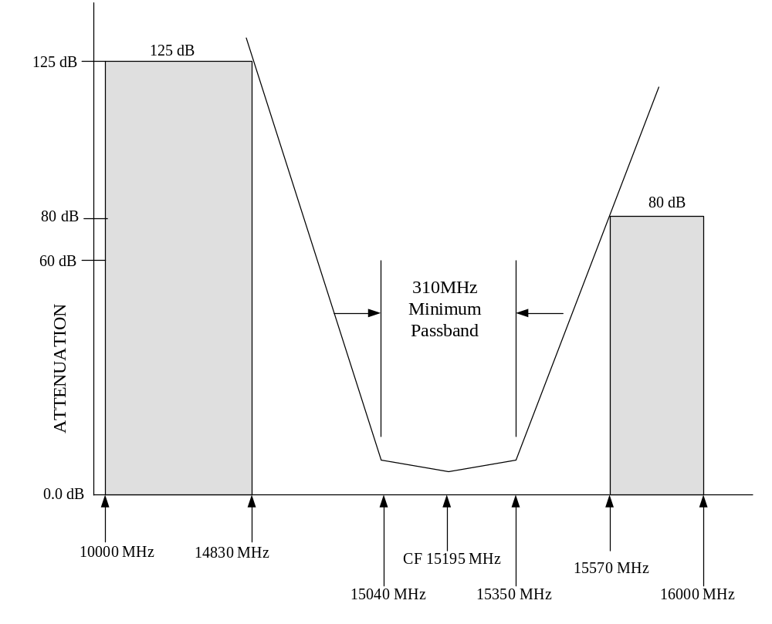
Figure 2 Diplexer Characteristics – Ku-Band STD-CDL FL/N-CDL OL Channel
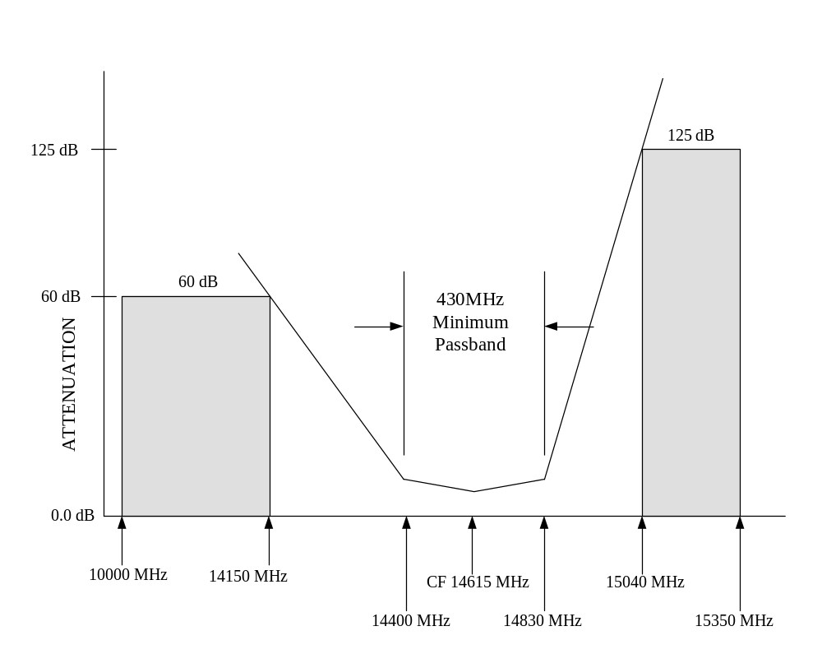
Figure 3 Diplexer Characteristics – Ku-Band STD-CDL RL/N-CDL IL Channel

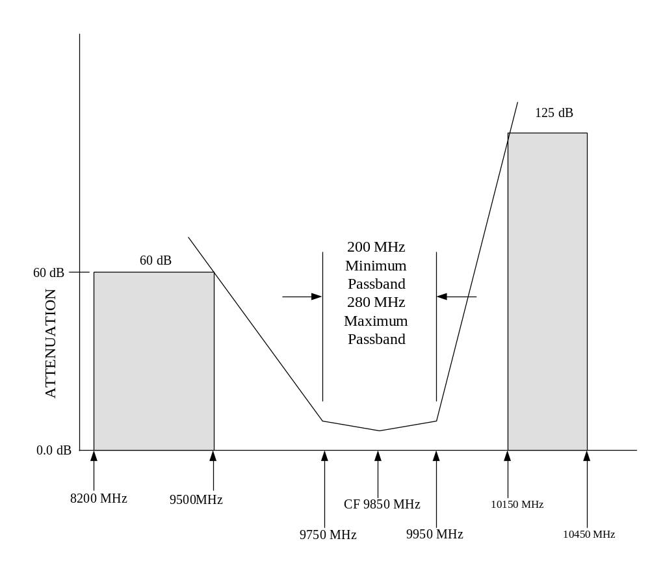
Figure 4 Diplexer Characteristics – X-Band STD-CDL FL

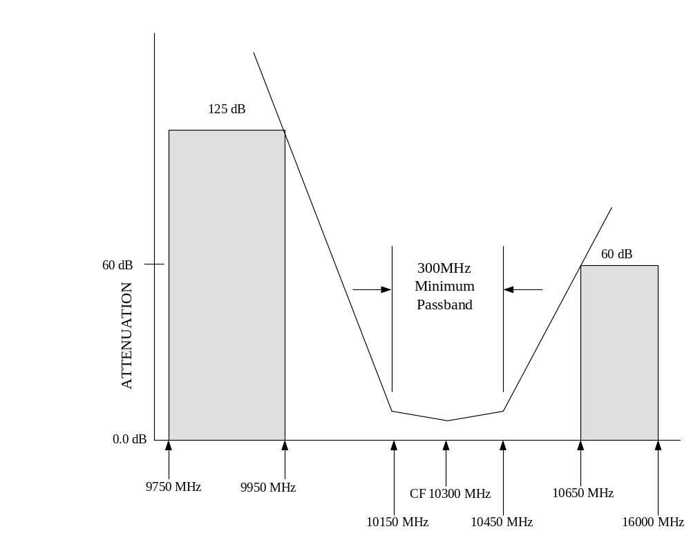
Figure 5 Diplexer Characteristics – X-Band STD-CDL RL

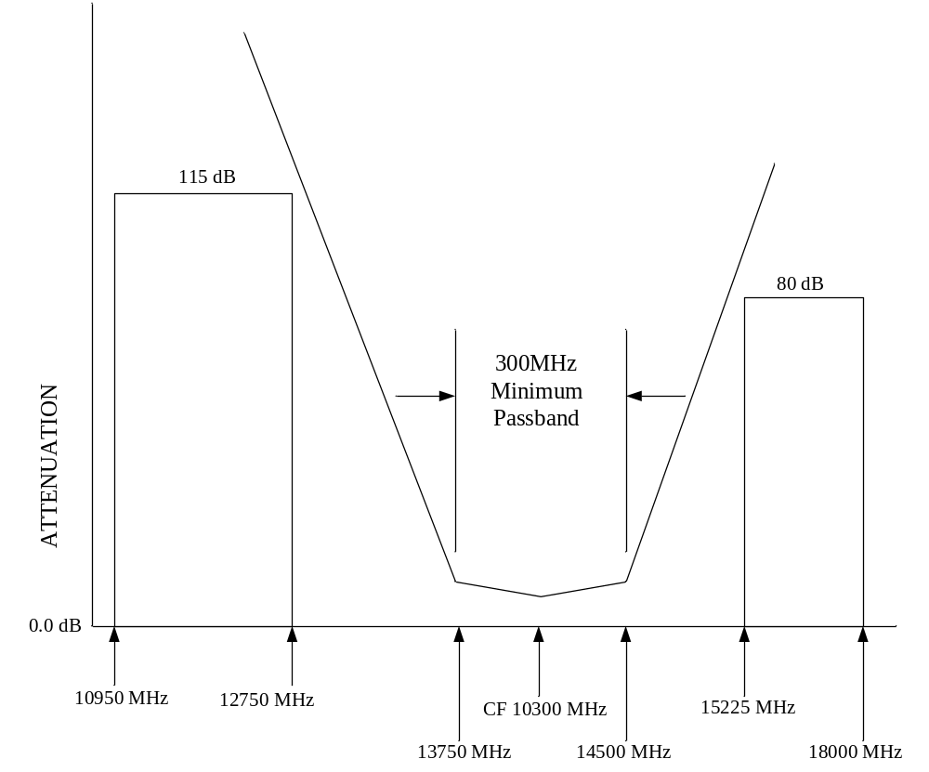
Figure 6 Filter Characteristics – Intelsat Uplink Characteristics

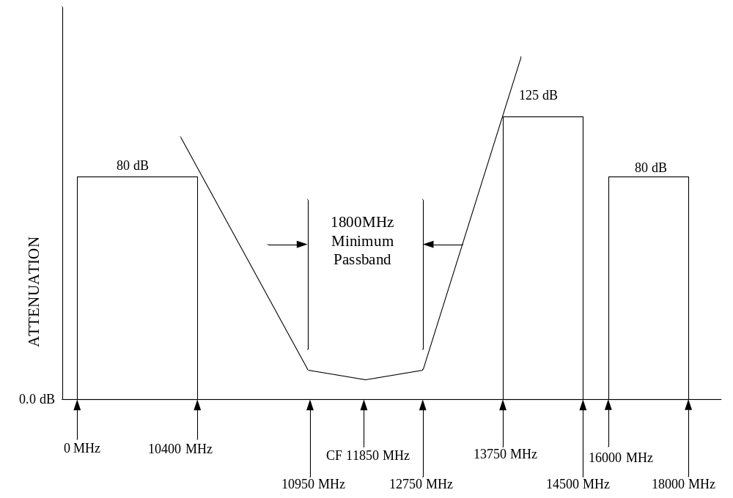
Figure 7 Filter Characteristics – Intelsat Uplink Characteristics

Amplitude Variation

CDL/NCDL Amplitude Variation
The RFE passband amplitude variations shall not exceed the limits shown in Table 13, variation RPL2 over any frequency band of W2 MHz (excluding the central W1 MHz), with variation RPL1 in the central frequency region of W1 MHz as shown in Figure 8, within the filter bandwidths defined in Table 11 for transmit operation.
The gain variation shall be normalized to the passband gain slope (best normalized, straight-line fit to the gain versus frequency relationship) over the filter bandwidths. The gain slope over the filter bandwidth shall not exceed the limits shown in Table 13, though a larger positive gain slope may be acceptable to compensate for other system elements gain slope. The amplitude variations shall not exceed those shown in Table 13 (in the “Max Variation” column) within W2.

Table 13 - CDL Amplitude Variation
Band | W1 (MHz) | RPL1 (dB p-p) | W2 (MHz) | RPL2 (dB p-p) | Gain Slope (dB) | Max Variation (dB/MHz)
Ku-Band STD-CDL FL | 75 | 0.3 | 150 | 0.6 | ± 0.3 | 0.03
Ku-Band STD-CDL RL | 150 | 0.5 | 300 | 0.8 | ± 0.50 | 0.04
Ku-Band NCDL IL (Tx) | 75 | 0.3 | 150 | 0.6 | ± 0.3 | 0.03
Ku-Band NCDL OL (Rx) | 75 | 0.3 | 150 | 0.5 | ± 0.3 | 0.025
X-Band STD-CDL FL (Tx) | 75 | 0.25 | 150 | 0.4 | ± 0.2 | 0.05
X-Band STD-CDL RL (Rx) | 75 | 0.4 | 150 | 0.6 | ± 0.3 | 0.05

Intelsat Amplitude Variation
The RFE passband amplitude variations shall not exceed the limits shown in Table 14, variation RPL2 over any frequency band of W2 MHz (excluding the central W1 MHz), with variation RPL1 in the central frequency region of W1 MHz as shown in Figure 8, within the filter bandwidths defined in Table 11 for transmit operation.
The gain variation shall be normalized to the passband gain slope (best normalized, straight-line fit to the gain versus frequency relationship) over the filter bandwidths. The gain slope over the filter bandwidth shall not exceed the limits shown in Table 16, though a larger positive gain slope may be acceptable to compensate for other system elements gain slope. The amplitude variations shall not exceed 0.03 dB/MHz within W2.

Table 14 - Intelsat Amplitude Variation
Mode | W1 (MHz) | RPL1 (dB p-p) | W2 (MHz) | RPL2 (dB p-p) | Gain Slope (dB)
Receive | 40 | 0.30 | 70 | 0.50 | ± 0.8
Transmit | 40 | 0.45 | 70 | 0.65 | ± 0.3

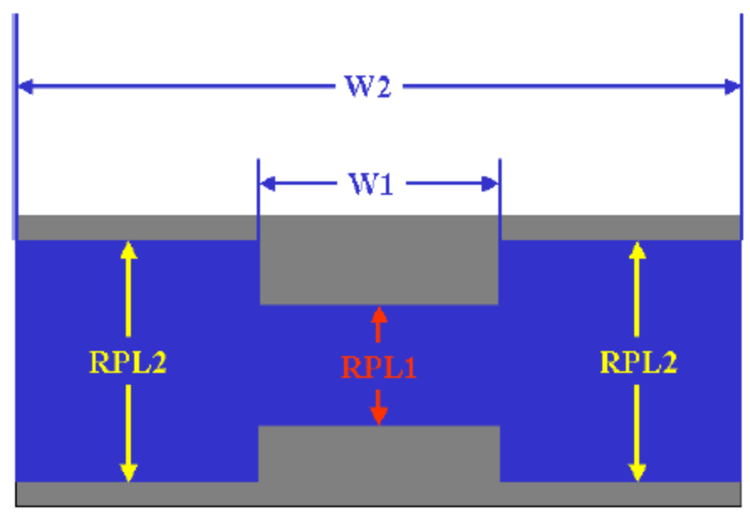
Figure 8 - Amplitude Variation

Group Delay Variation

CDL/NCDL Group Delay Variation
The RFE passband group delay variations shall not exceed the limits shown in Table 15 for Ku-band operational modes and Table 16 for X-band operational modes, over any frequency range window of W3 MHz, within the filter bandwidths defined in Table 10 for transmit operation. The difference between the group delay variations at the filter passband edges shall not exceed 20% of the DLY3 value for Ku-Band and 25% of DLY3 for X-Band.
The frequency bandwidth of W1 MHz shall be centered within the W2 bandwidth, which is centered within the W3 bandwidth as shown in Figure 9.
Limited excursions on the group delay variation spec may be allowed at customer discretion. The following conditions are acceptable excursions of performance beyond specification.
X-Band STD-CDL RL (Rx): Total excursions in any W3 window shall not exceed a total BW of 15 MHz and shall not extend more than 0.7 ns beyond the spec.
Table 15 - Ku-Band CDL/NCDL Group Delay Variation
Band | W1 (MHz) | DLY1 (nS) | W2 (MHz) | DLY2 (nS) | W3 (MHz) | DLY3 (nS)
Ku-Band STD-CDL FL | 75 | 1.8 | 100 | 3.0 | 150 | 5.8
Ku-Band STD-CDL RL | 150 | 1.7 | 200 | 2.0 | 300 | 4.9
Ku-Band NCDL IL (Tx) | 60 | 2.0 | 100 | 4.0 | 150 | 6.5
Ku-Band NCDL OL (Rx) | 75 | 2.0 | 100 | 3.0 | 150 | 5.8

Table 16 - X-Band CDL Group Delay Variation
Band | W1  (MHz) | DLY1  (nS) | W2  (MHz) | DLY2  (nS) | W3  (MHz) | DLY3  (nS)
X-Band STD-CDL FL (Tx) | 75 | 2.0 | 100 | 3.0 | 150 | 6.8
X-Band STD-CDL RL (Rx) | 75 | 2.0 | 100 | 3.0 | 150 | 6.8

Intelsat Group Delay Variation

The RFE passband group delay variations shall not exceed the limits shown in Table 17 over any frequency range window of W3 MHz, within the filter bandwidths defined in Table 11 for transmit operation. The frequency bandwidth of W1 MHz shall be centered within the W2 bandwidth, which is centered within the W3 bandwidth as shown in Figure 9.
Table 17 - Intelsat Group Delay Variation
Mode | W1 (MHz) | DLY1 (nS) | W2 (MHz) | DLY2 (nS) | W3 (MHz) | DLY3 (nS)
Receive | 40 | 0.8 | 50 | 1.2 | 70 | 2.1
Transmit | 40 | 0.7 | 50 | 1.0 | 70 | 1.7

Antenna Switch Isolation
The isolation between either WR75 Waveguide port of the RFE and the J19 Port of the RFE shall be a minimum of 60 dB for any CDL band operation.

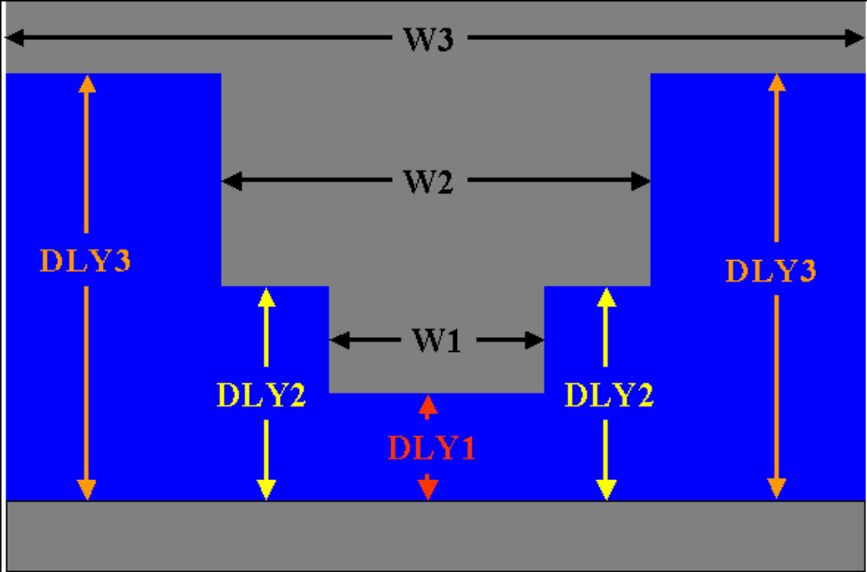
Figure 9 - Group Delay Variation

Control and Status Devices

Signal Format
The signal format shall be TTL and defined as follows:
Logic “1” Voltage: +2.5V to +5.0V.
Logic “0” Voltage: -0.3V to +0.7V.

Switching Speed
Switches shall be in its commanded state within 100 milli-seconds of the command lines transitioning.

Receive Amplifier Current Sensor
Electrical current through receive amplifiers shall be monitored to satisfy MTTR and BIT requirements. The data from this sensor shall be available on pins J12-10, J12-11, and J12-12. The signals sent from the LNA shall be as defined below in Table 18.

Table 18 – LNA Current Monitor Definition
LNA Designation | Signal Level | LNA Current
Ku | TTL High | Over/Under Current
Ku | TTL Low | Operational
X | TTL High | Over/Under Current
X | TTL Low | Operational
Intelsat | TTL High | Over/Under Current
Intelsat | TTL Low | Operational

Built-In-Test (BIT) Characteristics
The RFE shall be capable of configuring a test loop for the purpose of testing the functionality of both the Transmit and Receive functions and the components in the RF path. The test circuitry shall be designed to cause minimal impact on the overall mean time between failure (MTBF) of the Antenna Assembly. The test circuitry shall also be designed such that its failure will not prevent the Antenna Assembly from performing its normal transmission and reception functions. The built-in test configuration shall be set via appropriate switch commands on the J12 connector.
For any transmit band frequency input to either the WR62 or WR90 waveguide port the corresponding signal shall be attenuated by a minimum on 60 dB when measured at Port J18 for any normal mode of operation with no receive RF input signal.
In BIT mode the Gain from the RHCP/Intelsat antenna feed interface to the J18 receive output shall be 0 dB TBD minimum for Ku-Band and X-Band CDL and +5 dB TBD minimum for Ku-Band Intelsat.

Switch Commands and Status

Switch Commands
The RFE shall receive TTL commands to configure the switches within the RFE via the command lines on J10 according to the operational mode. The definition of the commands to set the switches for each operational mode is contained in Table 19 through Table 21.
Table 19 – Definition of RF Switch Commands

SAT 1743 RFE Switch Command Table
Freq. Mode | Antenna | Pos 1 = TTL High; Pos 2 = TTL Low, Pos X = Don’t Care |  |  |  |  |  |  |  |  |  |  | TX Band
Freq. Mode | Antenna | S1 POS | S2 POS | S3 POS | S4 POS | S5 POS | S6 POS | S7 POS | S8 POS | S9 POS | S10 MSB | S10 LSB | TX Band
1 | Directional | 1 | 1 | 2 | 2 | 2 | 2 | See Table 20 for Polarization definition. |  |  | 0 | 1 | Ku-CDL RL
1 | Widebeam | 1 | 1 | 2 | 2 | 2 | 1 |  |  |  | 0 | 1 | Ku-CDL RL
2 | Directional | 1 | 2 | 1 | 1 | 1 | 2 |  |  |  | 0 | 1 | Ku-CDL FL
2 | Widebeam | 1 | 2 | 1 | 1 | 1 | 1 |  |  |  | 0 | 1 | Ku-CDL FL
3 | Directional | 1 | 1 | 1 | 2 | 2 | 1 |  |  |  | 0 | 0 | X-CDL FL
3 | Widebeam | 1 | 1 | 1 | 2 | 2 | 1 |  |  |  | 0 | 0 | X-CDL FL
4 | Directional | 1 | 1 | 2 | 2 | 2 | 2 |  |  |  | 0 | 1 | NCDL IL
4 | Widebeam | 1 | 1 | 2 | 2 | 2 | 1 |  |  |  | 0 | 1 | NCDL IL
5 | Directional | 2 | X | X | X | X | 1 | 1 | 2 | 2 | 1 | 0 | Intelsat

Table 20 – RF Switch Commands for Circular Polarization Control
Directional Polarization Control (for CDL modes)
Antenna | Polarization | S7 POS | S8 POS | S9 POS
Directional | RHCP | 2 | 1 | 2
 | LHCP | 1 | 2 | 1

Table 21 – RF Switch Commands for BIT Mode
BIT Mode
 | S11 POS
Normal | 1
BIT | 2

RF Switching Status
The RFE shall send TTL status from the switches within the RFE via the status lines on J10. The definition of the status sent from the switches for each operational mode is contained in Table 22 through Table 24.

Table 22 – Definition of RF Switch Status
SAT 1743 RFE Switch Status Table
Freq. Mode | Antenna | Pos 1 = TTL High; Pos 2 = TTL Low, Pos X = Don’t Care |  |  |  |  |  |  |  |  |  |  |  | TX Band
Freq. Mode | Antenna | S1 POS | S2 POS | S3 POS | S4 POS | S5 POS | S6 POS | S7 POS | S8 POS | S9 POS | S10 POS1 | S10 POS2 | S10 POS3 | TX Band
1 | Directional | 2 | 2 | 1 | 1 | 1 | 1 | See Table 23 for Polarization definition. |  |  | 0 | 1 | 0 | Ku-CDL RL
1 | Widebeam | 2 | 2 | 1 | 1 | 1 | 2 |  |  |  | 0 | 1 | 0 | Ku-CDL RL
2 | Directional | 2 | 1 | 2 | 2 | 2 | 1 |  |  |  | 0 | 1 | 0 | Ku-CDL FL
2 | Widebeam | 2 | 1 | 2 | 2 | 2 | 2 |  |  |  | 0 | 1 | 0 | Ku-CDL FL
3 | Directional | 2 | 2 | 2 | 1 | 1 | 2 |  |  |  | 1 | 0 | 0 | X-CDL FL
3 | Widebeam | 2 | 2 | 2 | 1 | 1 | 2 |  |  |  | 1 | 0 | 0 | X-CDL FL
4 | Directional | 2 | 2 | 1 | 1 | 1 | 1 |  |  |  | 0 | 1 | 0 | NCDL IL
4 | Widebeam | 2 | 2 | 1 | 1 | 1 | 2 |  |  |  | 0 | 1 | 0 | NCDL IL
5 | Directional | 1 | X | X | X | X | 1 | 1 | 2 | 2 | 0 | 0 | 1 | Intelsat

Table 23 – RF Switch Status for Circular Polarization Control
Directional Polarization Status (for CDL modes)
Antenna | Polarization | S7 POS | S8 POS | S9 POS
Directional | RHCP | 1 | 2 | 1
 | LHCP | 2 | 1 | 2

Table 24 – RF Switch Status for BIT Mode
BIT Mode Status
 | S11 POS
Normal | 2
BIT | 1

Physical Characteristics

Size
Refer to Mechanical Interface Control Drawing, AMC Document Number 108818.

Weight
The weight of the RFE shall not exceed 32 pounds.

Cooling
The RFE shall be cooled by air convection, or a combination of air convection and heat radiation.

Reliability
The RFE (including all electrical, electronic, and electro-mechanical components) shall conform to the requirements specified in the following sub-paragraphs.

Mean Time Between Failure (MTBF)
The Mean Time Between Failures (MTBF) for the RFE (including all electrical, electronic, and electromechanical components) shall be > 35,000 (hours) at an ambient temperature of +49C in a ground fixed environment.

Service Life
The RFE shall be capable of withstanding operational, thermal, shock, and vibration environmental stresses over the warranty lifetime of the product. The environmental stresses shall be based on normally occurring distributed thermal and vibration values. The product design shall not preclude the ability for the customer to perform regular maintenance and/or component replacement in order to keep the equipment operational for up to a 20-year service life.

Maintainability

Maintainability Design Provisions
The RFE design shall include the following features:
Modules / Subassemblies and cable connections (except for coaxial, fiber optic, twinaxial, and legacy egress connections) shall have mechanical indexing or keying to preclude improper connections.
Plug-in, quick disconnect connections shall be employed to the maximum extent possible.
Critically tuned or temperature sensitive circuits shall have self-compensating features which preclude the necessity for alignment or module selective matching.
Scheduled calibration, warm-up and alignment requirements shall be minimized. Except for components on the Antenna, or electronics associated with antenna tracking functions, no Modules / Equipment / System alignment shall be required when any one, or combination, of these units is replaced.

Continuous Built-in Test (CBIT)
Continuous (Mission Mode) BIT shall be capable of detecting 90% of all failures that occur during system operation. The false alarm rate shall not exceed 2% where a false alarm is defined as the indication of a failure condition, which cannot be verified by retest or fault isolation.

Initiated Built-In-Test (IBIT)
IBIT shall be capable of detecting 98% of all failures, which could occur during normal equipment operation.

Environmental Conditions
Unless otherwise specified, the RFE assembly shall meet all electrical and mechanical requirements of this specification during and after exposure to the following environmental conditions.

Low Pressure (Altitude)

Operational
The equipment shall operate as specified in low pressure conditions to an equivalent altitude of up to 15,000 feet above sea level.

Non-Operational
The equipment shall be designed to withstand storage and transport in low pressure non-operating conditions to an equivalent altitude of up to 60,000 feet above sea level.

Ambient Temperature
The equipment shall be designed to perform as specified when exposed to the temperature extremes defined in the following sub-paragraphs.

Ambient Air Temperature, Non-Operational (Transit and Storage)
The equipment shall be designed to withstand temperatures from -40°C to +71°C during transportation and storage. Temperature requirements shall be derated per MIL-HDBK-5400, Figure 1, Class 1B, Curve B.

Ambient Air Temperature, Operational
The equipment shall be designed to operate without degradation from -40°C to +71°C ambient air temperature. Temperature requirements shall be derated per MIL-HDBK-5400, Figure 1, Class 1, Curve A (adjusted to account for +49°C at sea level versus +55°C as depicted by Curve A; a delta of 6°C).

Temperature Shock
The equipment shall be capable of enduring a 10°C/minute thermal shock environment per RTCA/DO-160D, Section 5.

Contamination by Fluids
The equipment shall be designed to withstand the effects of occasional contamination by fluids as defined in MIL-STD-810F, Table 504-I, Insecticides and Disinfectants only. “Occasional” exposure shall be as defined by MIL-STD-810F, Method 504, Paragraph 1.1 (Extraordinary/unusual circumstances occurring once or twice a year).
Additionally, the equipment shall be designed to withstand the effects of intermittent contamination by fluids as defined in MIL-STD-810F, Table 504-I, deicing compounds. “Intermittent” exposure shall be as defined by MIL-STD-810F, Method 504, Paragraph 1.1 (Regular basis under normal operation; possibly seasonally over the life of the material).

Solar Radiation
The equipment shall be designed to operate under Solar Radiation conditions as defined in MIL-STD-810F, Method 505.4, paragraph 2.3.1, Cycle A1, Worldwide deployment. Peak conditions are 1120 W/m² and +49°C. Diurnal solar radiation levels per MIL-STD-810F, Method 505.4, Figure 505.4-1.

Rain
The equipment shall be designed to operate in rainfall conditions per STANAG 2895, Annex C, Paragraph 29, Table 28, World-wide conditions, column b, 0.80 mm/min.

Humidity
The equipment shall be designed to meet humidity conditions ranging up to 100 percent relative humidity with condensation.

Fungus
The equipment shall be designed to withstand the effects of fungal growth by using fungus inert materials. Fungus contaminants considered in analysis shall be per MIL-STD-810F, Method 508.5, Table 508.5-I, European and U.S. Standards.

Salt Fog
The assembly shall be resistant to the corrosive effects of salt-fog atmosphere as specified in MIL-STD-810F Method 509.4, 5% solution.

Sand and Dust
The part of the assembly exposed to the environment shall withstand, both operating and non-operating, the conditions of atmospheric dust as defined in STANAG 2895, Annex C, Table 31, 1.0 G/m³. The conditions for sand and dust shall be considered “Blowing Sand and Dust” as defined by MIL-STD-810F, paragraph 2.2.2.

Explosive Atmosphere
The equipment shall not cause ignition of explosive atmosphere conditions as defined by MIL-STD-810F, Method 511.4, paragraph 2.2.2

Vibration
The vibration requirement is defined in two categories, Transportation (non-operational), and Operational conditions. Transportation requirements apply to the equipment as prepared for shipping and handling. Operational requirements apply to the equipment as deployed for operation.

Transportation Vibration Requirements, Non-Operational
The assembly shall survive transportation vibration as defined in MIL-STD-810F, Method 514.5, Table 514.5-I, Categories 4,7,8,10,11 as shown in Figure 10.
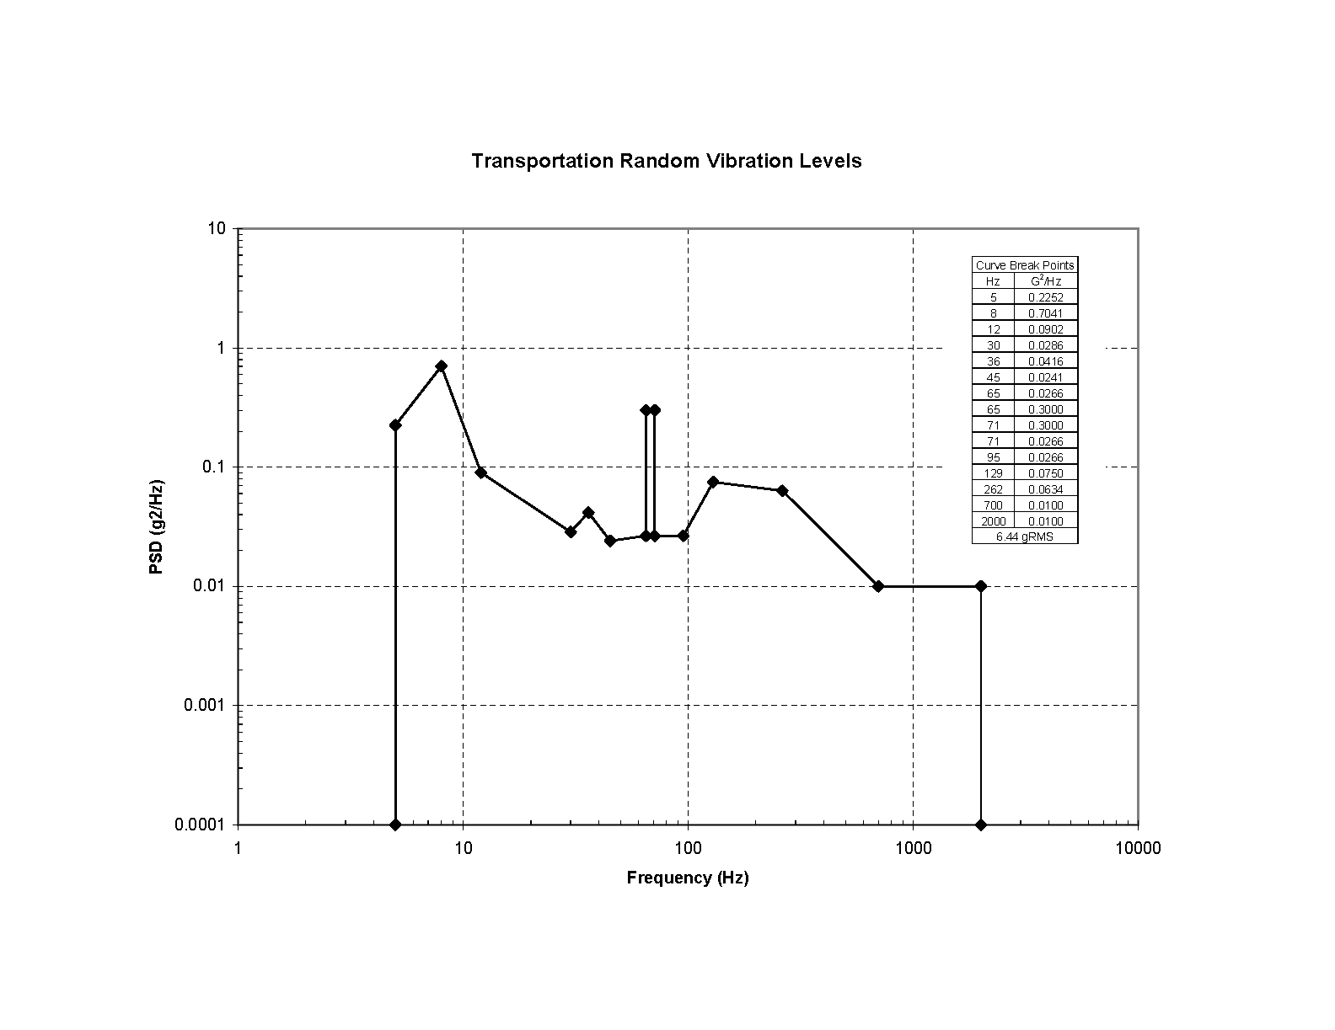
Figure 10 – Transformational Vibration, Non-Operational

Operational Vibration Requirements
Operational requirements apply to the equipment as deployed for operation.
The equipment shall operate when exposed to a 0.05g peak acceleration from 4 to 8 Hz and a constant 10 mm/s peak velocity between 8 and 100 Hz. Recommended testing should include 10 total sweep cycles between 4 and 100 Hz at a bidirectional sweep rate of 1.0 octave/minute (reference Figure 11 below).
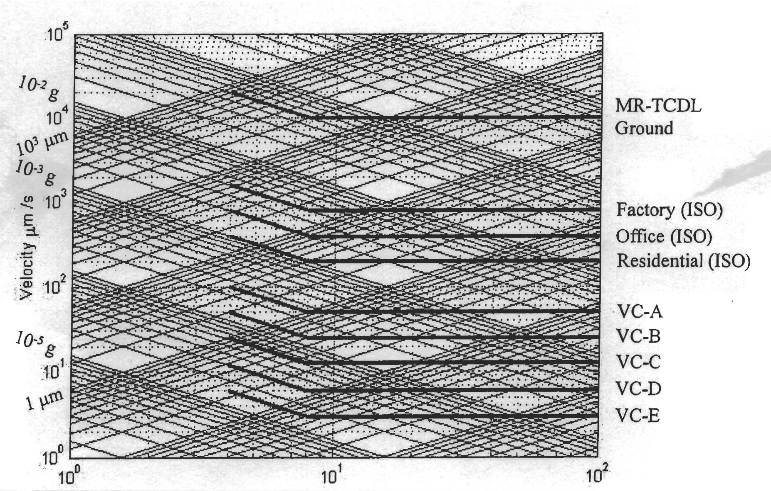
Figure 11 - Operational Vibration Spectrum

Endurance Vibration Requirements
Operational requirements apply to the equipment as deployed for operation.
The equipment, in an operational mode, shall survive without damage in the vibration environment as defined in ETS 300 019-1-4. The equipment is not required to meet functional requirements while subjected to this environment. The vibration spectrum shall be per Figure 12.
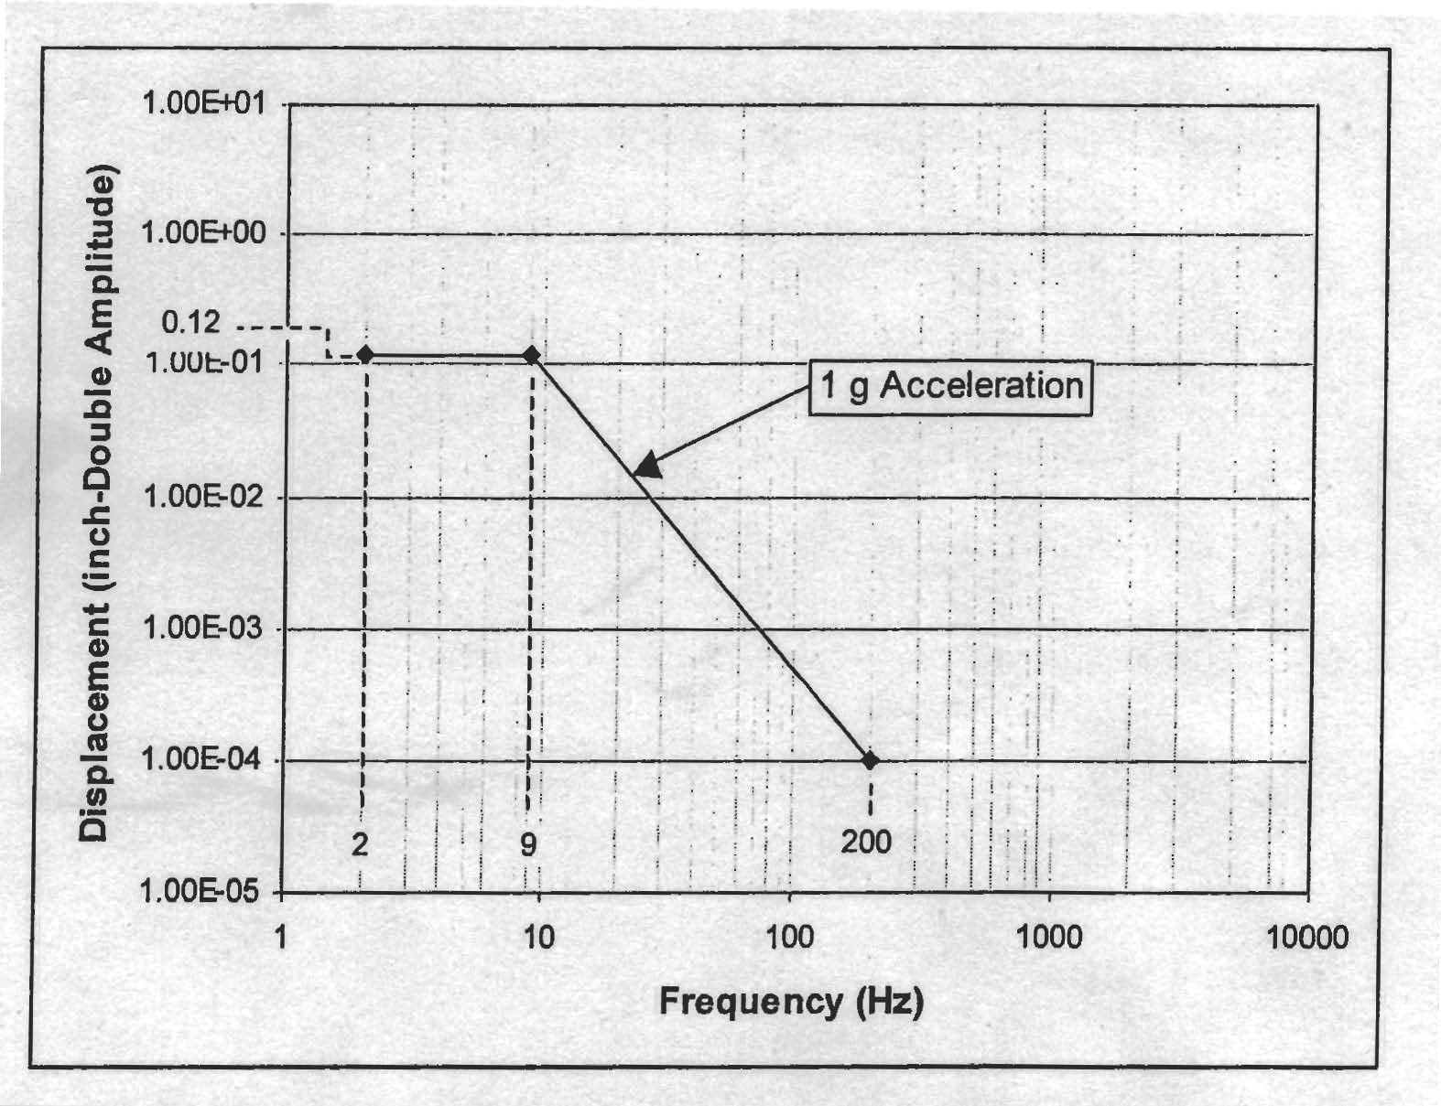
Figure 12 - Endurance Vibration Spectrum

Shock
The equipment shall be designed to shock environments including functional shock and Bench Handling shock. Shock levels shall be per MIL-STD-810F, Method 516.5, Table 516.5-I.

Functional Shock Environment
The assembly shall operate during a 25g, 6ms shock event as defined by ETS 300 019-1-4, Table 5 and Figure 11.

Bench Handling Shock
The equipment shall survive Bench Handling shock as described by MIL-STD-810F, Method 516.5, Procedure VI (paragraph 4.5.7).

Temperature, Humidity, Vibration, and Altitude
The equipment shall be designed to withstand the effects of temperature, humidity, vibration and altitude combinations while in operation. Temperature requirements shall be derated per MIL-HDBK-5400, Figure 1, Class 1B, Curve A. Specific conditions for combined environments shall be per the individual requirements sections in this document.

Icing, Freezing Rain
The equipment shall be designed to survive while operating under conditions of icing and freezing rain as defined in MIL-STD-810F, Method 521.2, paragraph 2.2.7, line b, 13mm – general conditions, medium loading. Performance degradation is allowable under icing/freezing rain conditions.

Ballistic Shock
The equipment should meet the requirements for ballistic shock as defined by MIL-STD-810F, Method 522, Tables 522-I and 522-II and Figure 522-1. This requirement is a goal.
Wind, Airspeed
The RFE shall be designed to operate in winds up to 30 MPH and withstand (survive), while operating, a maximum wind speed of 52 MPH steady and gusts to 73 MPH per STANAG 2895, Annex C, when properly secured. Performance degradation is allowable under high wind (over 30 MPH) conditions.

Design and Construction

Materials, Processes, and Parts

Metals and Alloys
Metals and alloys shall be corrosion resisting or shall be given a corrosion-resistant treatment or coatings. Dissimilar metals shall be treated to prevent galvanic corrosion per MIL-STD-889. Aluminum not otherwise treated shall be treated in accordance with MIL-DTL-5541. Stainless steel fasteners in aluminum shall be treated with Zinc Chromate primer per TT-P-1757 or another suitable method.

Nonmagnetic Materials
Nonmagnetic materials shall be used in all parts of the equipment except where the use of magnetic materials is required for proper performance.

Structural Strength
Materials used in the equipment shall possess sufficient structural strength and fatigue life to satisfy environmental service conditions and service life requirements.

Corrosion Protection/Corrosion-Resisting Treatments
Unless otherwise specified, corrosion-resisting treatments shall not be applied to surfaces, which are in functional contact where gouging or binding may be a factor, where the treatment might interfere with normal functioning, or where electrical grounding through the surface is required.

Electromagnetic Interference (EMI) / Electromagnetic Compatibility
The RFE shall meet the requirements of the recommended tests of MIL-STD-461. Tests and test requirements shall be as specified in the contract, as modified in Table 25.

Table 25 - EMI/EMC Requirements
Test | EMC / EMI Condition
CE102 | Conducted Emissions, Power Leads, 10 kHz to 10 MHz
CE106 | Conducted Emissions, Antenna Terminal, 0.8 X Waveguide cutoff frequency to 40 GHz
CS101 | Conducted Susceptibility, Power Leads, 30 Hz or 2 X Power Freq. to 150 kHz
CS114 | Conducted Susceptibility, Bulk Cable Injection, 10 kHz to 200 MHz
CS115 | Conducted Susceptibility, Bulk Cable Injection, Impulse Excitation
CS116 | Conducted Susceptibility, Damped Sinusoidal Transients, Cables and Power leads, 10kHz to 100 MHz
RE101 | Radiated Emissions, Magnetic Field, 30 Hz to 100 kHz
RE102 | Radiated Emissions, Electric Field, 2 MHz to 18 GHz
RS101 | Radiated Susceptibility, Magnetic Field, 30 Hz to 100 kHz
RS103 | Radiated Susceptibility, Electric Field, 2 MHz to 18 GHz, 50V/m

Product Marking

Identification and Product Marking
Identification and product marking of all units and assemblies, electrical and moving mechanical parts, and any mechanical parts required to be removed for normal maintenance, shall conform to MIL-STD-130, as applicable.

Marking for Shipment
Identification and marking of all units and assemblies for shipment shall conform to MIL-STD-129, as applicable.

Marking for ESD
Identification and marking of all units and assemblies that may be susceptible to ESD shall conform to MIL-STD-1686, as applicable.

Workmanship
The RFE, including all parts and accessories, shall be constructed and finished in accordance with MIL-STD-454 Requirement 5 and 9. Internal wiring shall be done in accordance with IPC/WHMA-A-620.

Interchangeability
All hardware modules, assemblies, subassemblies, mechanical parts, and other elements, will be interchangeable utilizing MIL-STD-454, Requirement 7 and accessible utilizing MIL-STD-454, Requirement 36 as a guide. All parts having the same manufacturer's part number will be functionally and dimensionally interchangeable. This applies to production units.

Safety
The antenna assembly will be designed such that the possibility of personal injury during installation, test, operation, maintenance, and removal of the hardware is minimized. The system will be designed so that operator/maintenance personnel that follow specified procedures cannot cause equipment failure or personal injury. Malfunctions of the equipment will not contribute to the destruction of said equipment. The provisions of MIL-HDBK-454, Requirement I and MIL-STD-1472, paragraph 5.13 and MIL-STD-882 will be used as a guide.

Equipment Safety
Design of equipment will provide for adequate protection to equipment as well as maximum safety to personnel engaged in operation and maintenance as follows:
Protective guards, shields, louvers, and covers will be provided to prevent personnel contact with moving parts during normal operating conditions.
Equipment will be designed for safe maintenance but will be labeled with appropriate warnings or cautions to avoid risk of human injury during potentially hazardous maintenance operations.

Radiation
Except for the antenna there shall be no radiation emitted from the other subassembly which may be harmful to personnel. Precautions shall be taken to prevent radiation hazard to personnel when performing tests requiring emissions from the antenna.

Electrical Protection
The RFE shall prevent equipment damage whenever an electrical power condition exists within the limits of abnormal power as specified in MIL-STD-704E and as tailored by the program.

Human Performance/Human Engineering
Human factors engineering shall be applied during all phases of the RFE hardware and software equipment design and development. The effort shall cover all aspects of the equipment design using MIL-STD-1472 as a guide with particular emphasis on design for maintainability, design for hazards, and safety.

Accessibility
Accessibility shall comply with the requirements specified in MIL-STD-1472 except as specified herein. Chassis withdrawal slides, if any, shall be provided with automatically operated locks to lock the chassis in both the operating and service positions.

Accidental Activation
The design to prevent accidental activation shall conform to the requirements of MIL-STD-1472.

Precedence
Precedence of requirements shall be as set forth in the contract. In regard to specifications, the order or precedence is system specification, subsystem specification, and LRU specification. In the event of conflict between this specification and referenced documents, this specification shall take precedence.

Quality Assurance Provisions
The following tests, analyses, and inspections shall be performed. When approved by AMC, the manufacturer’s alternate methods may be used. Approval shall be requested and obtained for each purchase order.

Acceptance Requirements
All assemblies shall be subjected to the following tests and inspections in accordance with AMC approved manufacturer generated Acceptance Test Procedure (ATP). Assemblies that fail the testing shall not be shipped.

Verification Matrix
The methods of verification are defined in Table 26..

Test Data and Certifications
Test verification documents shall be supplied with each lot of assemblies shipped. These shall include copies of final electrical test data identifiable to the individual assembly tested, results of the screening and/or qualification tests and inspections, applicable written analyses and a certificate certifying that all assemblies shipped, successfully complied with the quality assurance provisions of this drawing. The certificate shall also include the following:
  - AMC part number.
  - Assembly serial numbers and date code of manufacture.
  - Identification numbers of the ATP and/or QTP used for testing, as applicable.
  - Date of acceptance.
Table 26 - Requirements Verification Matrix
N/A - Not Applicable |  | A - Analysis/Similarity |  |  | T - Test
TI - Title Only (N/A) |  | I - Inspection |  |  | QT - Qualification Test
LI - Lead in paragraph (N/A) |  | D - Demonstration |  |  | AT - Acceptance Test
Paragraph | Title Final Acceptance Method |  | Method of Verification |  |  |  |  |  | Ver Type
Paragraph |  |  | N/A | I |  | A | D | T | QT | AT
3 | Requirements |  | LI
3.1 | Item Definition |  |  | X
3.1.1 | Item BOM |  |  | X
3.1.2 | Item Diagrams |  | LI
3.1.3 | External Interface Definition |  |  | X
3.1.3.1 | Power and Command Connector Definition |  |  | X
3.1.3.2 | RF Connector Definition |  |  | X
3.1.3.3 | Waveguide Port Definition |  |  | X
3.1.3.4 | Receive Input Signal Characteristics |  | TI
3.1.3.4.1 | Over-the-air Receive Input Interface |  |  |  |  |  |  | X | X | X
3.1.3.5 | Receive Output Signal Characteristics. |  |  |  |  |  |  | X | X | X
3.1.3.6 | TRANSMIT RF Signal Interfaces. |  | TI
3.1.3.6.1 | TRANSMIT RF Output Interfaces |  |  |  |  |  |  | X | X | X
3.1.3.6.2 | TRANSMIT RF Input Signal Characteristics |  |  |  |  |  |  | X | X | X
3.1.3.7 | VSWR |  | LI
3.1.3.7.1 | Receive RF Output (J18) |  |  |  |  |  |  | X | X | X
3.1.3.7.2 | Widebeam Antenna (J19) |  |  |  |  |  |  | X | X | X
3.1.3.7.3 | Ku-Band Transmit (WR62 Flange) |  |  |  |  |  |  | X | X | X
3.1.3.7.4 | X-Band Transmit (WR90 Flange) |  |  |  |  |  |  | X | X | X
3.1.3.7.5 | RHCP/Intelsat Transmit (WR75 flange) |  |  |  |  |  |  | X | X | X
3.1.3.7.6 | LHCP/Intelsat Receive (WR75 flange) |  |  |  |  |  |  | X | X | X
3.1.3.8 | Input Prime Power |  | TI
3.1.3.8.1 | Prime Power Type |  |  |  |  | X |  |  | X
3.1.3.8.2 | Power Consumption |  |  |  |  |  |  | X | X | X
3.1.3.9 | Chassis Ground |  |  |  |  |  |  | X | X
3.2 | Characteristics |  | TI
3.2.1 | Performance Characteristics |  | TI
3.2.1.1 | Channel Characteristics |  | TI
3.2.1.1.1 | Ku-Band STD-CDL FL/N-CDL OL Channel |  |  |  |  |  |  | X | X | X
3.2.1.1.2 | Ku-Band STD-CDL RL/N-CDL IL Channel |  |  |  |  |  |  | X | X | X
3.2.1.1.3 | X-Band STD-CDL FL Channel |  |  |  |  |  |  | X | X | X
3.2.1.1.4 | X-Band STD-CDL RL Channel |  |  |  |  |  |  | X | X | X
3.2.1.1.5 | Ku-Intelsat Uplink Channel |  |  |  |  |  |  | X | X | X
3.2.1.1.6 | Ku-Intelsat Downlink Channel |  |  |  |  |  |  | X | X | X
3.2.1.1.7 | Amplitude Variation |  | TI
3.2.1.1.7.1 | CDL/NCDL Amplitude Variation |  |  |  |  |  |  | X | X | X
3.2.1.1.7.2 | Intelsat Amplitude Variation |  |  |  |  |  |  | X | X | X
3.2.1.1.8 | Group Delay Variation |  | TI
3.2.1.1.8.1 | CDL/NCDL Group Delay Variation |  |  |  |  |  |  | X | X | X
3.2.1.1.8.2 | Intelsat Group Delay Variation |  |  |  |  |  |  | X | X | X
3.2.1.1.9 | Antenna Switch Isolation |  |  |  |  |  |  | X | X | X
3.2.2 | Control and Status Devices |  | TI
3.2.2.1 | Signal Format |  |  |  |  |  | X |  | X
3.2.2.2 | Switching Speed |  |  |  |  |  | X |  | X
3.2.2.3 | Receive Amplifier Current Sensor |  |  |  |  |  |  | X | X
3.2.2.4 | Built-In-Test (BIT) Characteristics |  |  |  |  |  |  | X | X | X
3.2.2.5 | Switch Commands and Status |  | TI
3.2.2.5.1 | Switch Commands |  |  |  |  |  |  | X | X | X
3.2.2.5.2 | RF Switching Status |  |  |  |  |  |  | X | X | X
3.2.3 | Physical Characteristics |  | TI
3.2.3.2 | Size |  |  | X |  |  |  |  | X | X
3.2.3.3 | Weight |  |  | X |  |  |  |  | X | X
3.2.6 | Cooling |  |  | X
3.2.7 | Reliability |  | LI
3.2.7.1 | Mean Time Between Failure (MTBF) |  |  |  |  | X
3.2.7.2 | Service Life |  |  |  |  | X
3.2.8 | Maintainability |  | TI
3.2.8.1 | Maintainability Design Provisions |  |  | X
3.2.8.2 | Continuous Built-in Test (CBIT) |  |  |  |  | X
3.2.8.3 | Initiated Built-In-Test (IBIT) |  |  |  |  | X
3.2.9 | Environmental Conditions |  | LI
3.2.9.1 | Low Pressure (Altitude) |  | TI
3.2.9.1.1 | Operational |  |  |  |  | X
3.2.9.1.2 | Non-Operational |  |  |  |  | X
3.2.9.2 | Ambient Temperature |  | LI
3.2.9.2.1 | Ambient Air Temperature, Non-Operational (Transit and Storage) |  |  |  |  | X
3.2.9.2.2 | Ambient Air Temperature, Operational |  |  |  |  | X
3.2.9.2.3 | Temperature Shock |  |  |  |  | X
3.2.9.3 | Contamination by Fluids |  |  |  |  | X
3.2.9.4 | Solar Radiation |  |  |  |  | X
3.2.9.5 | Rain |  |  |  |  | X
3.2.9.6 | Humidity |  |  |  |  | X
3.2.9.7 | Fungus |  |  |  |  | X
3.2.9.8 | Salt Fog |  |  |  |  | X
3.2.9.9 | Sand and Dust |  |  |  |  | X
3.2.9.10 | Explosive Atmosphere |  |  |  |  | X
3.2.9.11 | Vibration |  |  |  |  | X
3.2.9.11.1 | Transportation Vibration Requirements, Non-Operational |  |  |  |  | X
3.2.9.11.2 | Operational Vibration Requirements |  |  |  |  | X
3.2.9.11.3 | Endurance Vibration Requirements |  |  |  |  | X
3.2.9.12 | Shock |  | LI
3.2.9.12.1 | Functional Shock Environment |  |  |  |  | X
3.2.9.12.2 | Bench Handling Shock |  |  |  |  | X
3.2.9.13 | Temperature, Humidity, Vibration, and Altitude |  |  |  |  | X
3.2.9.14 | Icing, Freezing Rain |  |  |  |  | X
3.2.9.15 | Ballistic Shock |  |  |  |  | X
 | Wind, Airspeed |  |  |  |  | X
3.3 | Design and Construction |  | TI
3.3.1 | Materials, Processes, and Parts |  | TI
3.3.1.1 | Metals and Alloys |  |  | X
3.3.1.2 | Nonmagnetic Materials |  |  | X
3.3.1.3 | Structural Strength |  |  |  |  | X
3.3.1.4 | Corrosion Protection/Corrosion-Resisting Treatments |  |  | X
3.3.2 | Electromagnetic Interference (EMI) / Electromagnetic Compatibility |  |  |  |  | X |  | X | X | X
3.3.3 | Product Marking |  | TI
3.3.3.1 | Identification and Product Marking |  |  | X
3.3.3.2 | Marking for Shipment |  |  | X
3.3.3.3 | Marking for ESD |  |  | X
3.3.4 | Workmanship |  |  | X
3.3.5 | Interchangeability |  | X
3.3.6 | Safety |  | X
3.3.6.1 | Equipment Safety |  | X
3.3.6.2 | Radiation |  | X
3.3.6.3 | Electrical Protection |  |  |  |  | X
3.3.6.4 | Human Performance/Human Engineering |  |  | X
3.3.6.5 | Accessibility |  |  | X |  |  |  |  | X
3.3.6.6 | Accidental Activation |  |  | X |  |  |  |  | X
3.6 | Precedence |  | X
NOTES:
Inspection. Inspection is defined as visual, dimensional or measurement verifications to assure compliance as specified by approved documentation such as drawings, specifications, and processes.
Analysis/similarity. Analysis is defined as using recognized analytical techniques, including computer models, to interpret or explain systems, equipment, personnel behavior, or reduced and representative data. Analysis shall be used in lieu of or to supplement test data. Similarity is a method of verification where the requirement has been verified by inspection, analysis, demonstration, or test on a similar design and can be shown that the developmental item will also meet the requirement.
Demonstration. Demonstration is defined as performing uninstrumented operation on the element where visual observation is the primary means of verification. Demonstration is used when quantitative assurance is not required for verification.
Test. Test is defined as performing an operation to provide data of the properties and characteristics of the element under test, under the appropriate conditions and in accordance with approved test procedures. The data is subsequently used to evaluate quantitative characteristics of the element under test. Evaluation includes comparing the demonstrated characteristics with requirements. Tests are conducted when an acceptable level of confidence cannot be established by other methods, or if testing can be shown to be the most cost-effective method.

Preparation for Delivery
The manufacturer shall incorporate protective packaging measures designed to prevent shipping damage in accordance with Level C (minimum) of MIL-E-17555. The assemblies, thus packaged, shall arrive undamaged at the shipping destination.

Notes

Intended Use
The equipment covered by this specification is intended for use in an assortment of airborne data link LRU applications.

Acronyms and Abbreviations
The following acronyms and abbreviations are used in this specification:
A Analysis
AT Acceptance Test
ATP Acceptance Test Procedure
°C Degrees Celsius
CDRL Contract Data Requirements List
CF Center Frequency
CIDS Critical Item Development Specification
CM/DM Configuration Management/Data Management
Cond Conductor
Ctl Control
dB Decibel
dBW Decibel reference to Watt
DC Direct Current
deg Degree
Des Designation
DT Development Test
EIR Engineering Information Release
ESD Electrostatic Discharge
FT Flight Test
g Force due to gravity
GHz Gigahertz
Grms Gravitational Force Root Mean Squared
Gnd Ground
HDBK Handbook
Hz Hertz
I/O Input/Output
IN Inch
KHz Kilohertz
LI Lead in Paragraph
LNA Low Noise Amplifier
LRU Line Replaceable Unit
mA Milliamp
max Maximum
MHz Megahertz
MIL Military
min Minimum
MP-CDL Multi-Platform Common Data Link
MPH miles per hour
ms millisecond
MSL Mean Sea Level
mVpp Millivolt peak-to-peak
NA Not Applicable
NFC National Fire Code
ns nanosecond
PSD Power Spectral Density
QT Qualification Test
Ref Reference
Rev Revision
RF Radio Frequency
SC Single Conductor
SOCN Source Control Number
Sts Status
T Test
TBD To Be Determined
TBR To Be Reviewed
TI Title Only
TNC Threaded Neill-Concelman
TTL Transistor-to-Transistor Logic
V Volt
VAC Voltage Alternating Current
VDC Volts Direct Current
VSWR Voltage Standing Wave Ratio

